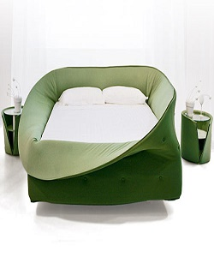

Bed

$359.47

Availability: In stock

Description

Sleeping in this Bed is like being nestled in a soft visual and sound barrier. The bed is a two tone color elastic fabric that ensures that the bed is always in order. Available in single, double, king and super king size and in various colors.